Supplementary material

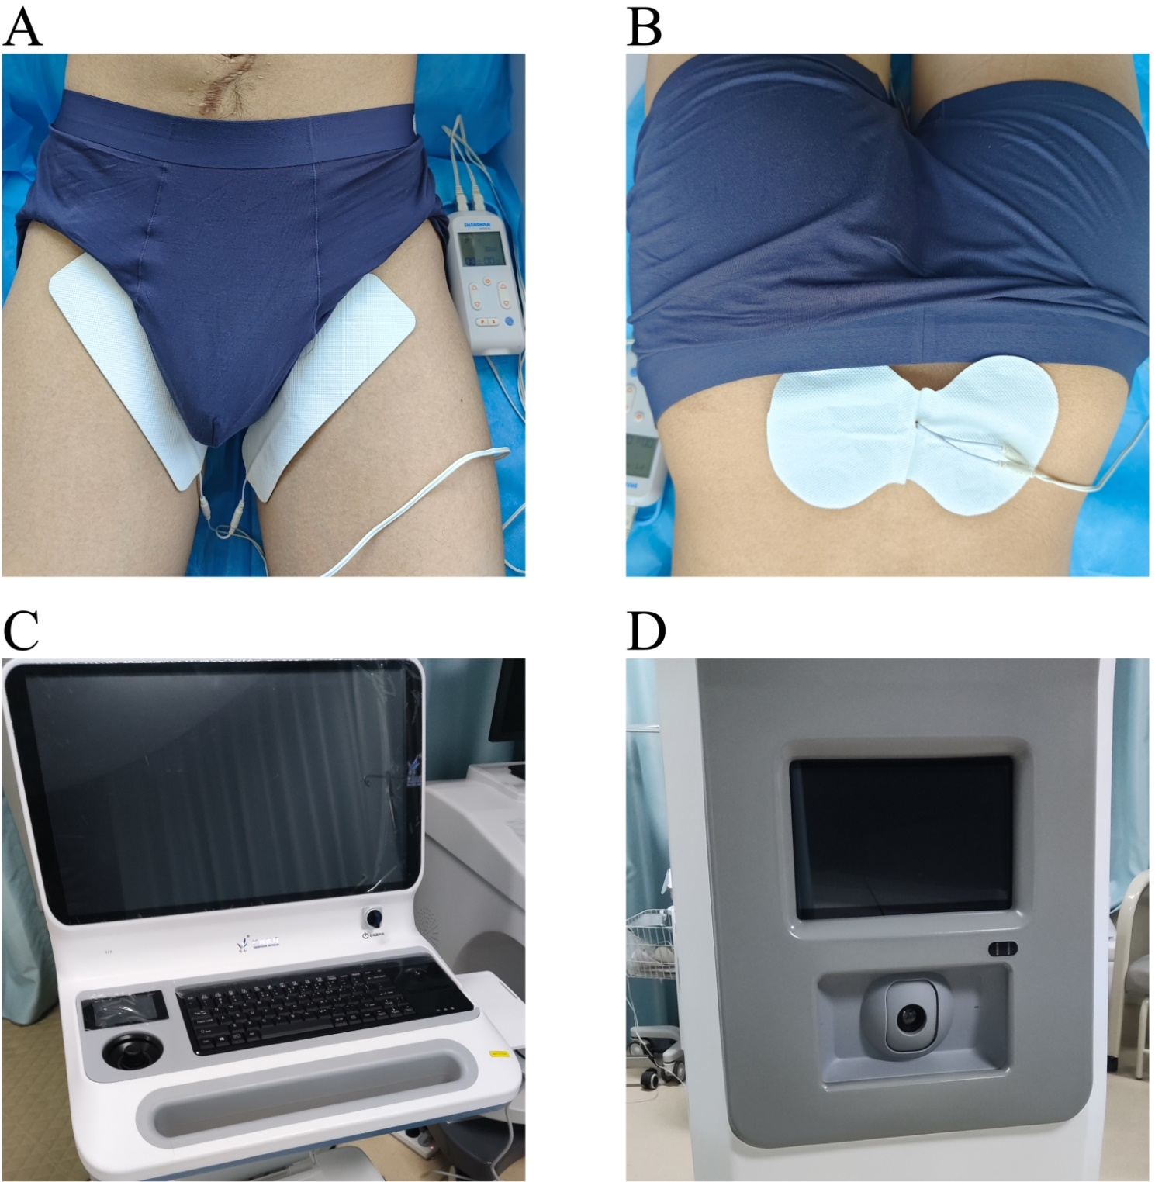
Supplementary Fig. 1. The scenario of the NMES treatment and details of the device. (A,B). The NMES was performed by stimulating the peripheral nerve around the perineurium and the sacral nerve at the level of S2–S4. (C,D). Infrared thermography was applied to evaluate the improvement caused by NMES.

